**JavaScript DOM-APIs**

Table of Contents

What is DOM? 2

Document & Window 2

How’s DOM Created? 3

Querying the HTML Elements 3

Nodes and Elements 4

Evaluating & Manipulating Elements 5

Properties Vs Attributes 5

Traversing the DOM [Children, Descendants, Parent and Ancestors] 6

Styling DOM Elements 7

Timing Events [setTimeout & setInterval] 7

JavaScript Popup Boxes 7

Event Listeners – Add/Remove 7

Events 8

# What is DOM?

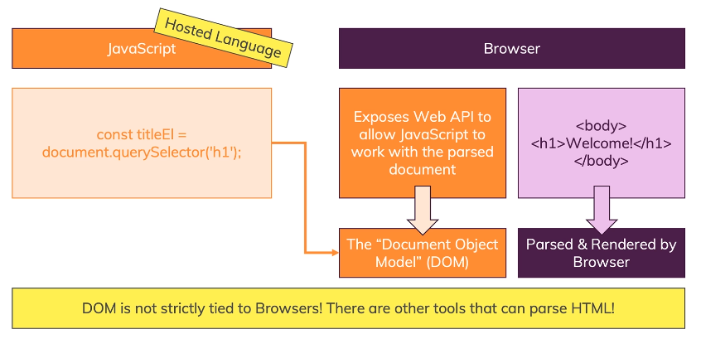

# Document & Window

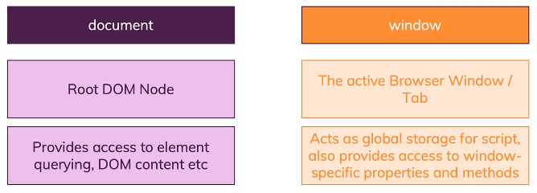

Go to console using the developer tools and type the following to look at both document and window.

* console.log(document)
* window
  + document is part of the window

# How’s DOM Created?

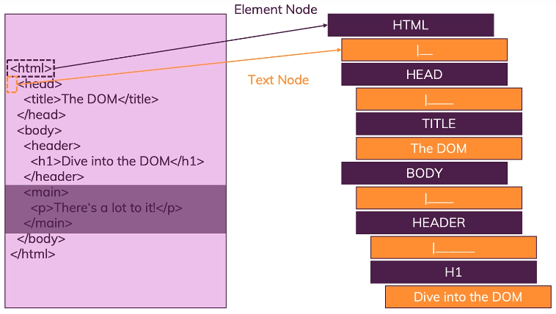

# Querying the HTML Elements

View Task 11 for more details

W3Schools is the best resource for finding all the ways an element can be accessed via JavaScript

1. <https://www.w3schools.com/jsref/dom_obj_all.asp>
2. <https://www.w3schools.com/jsref/dom_obj_document.asp>
3. <https://developer.mozilla.org/en-US/docs/Web/API/Document/querySelector>
4. <https://developer.mozilla.org/en-US/docs/Web/API/Document/getElementById>
5. <https://developer.mozilla.org/en-US/docs/Web/API/Document/querySelectorAll>
6. <https://developer.mozilla.org/en-US/docs/Web/API/Document/getElementsByClassName>
7. <https://developer.mozilla.org/en-US/docs/Web/API/Element/getElementsByTagName>
8. <https://developer.mozilla.org/en-US/docs/Web/API/Document/getElementsByName>

* document.getElementById('someId');
* document.getElementByClassName('someId');
* document.getElementsByTagName('li'); //use for of loop
* QuerySelector
  + by name: document.querySelector('input[name="rdoSelection"]:checked').value;
  + document.querySelector('li:last-of-type');
  + document.querySelector('ul li:first-of-type');
  + document.querySelectorAll('li');
* document.body;

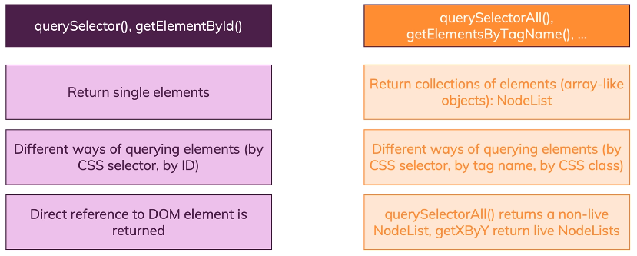

# Nodes and Elements

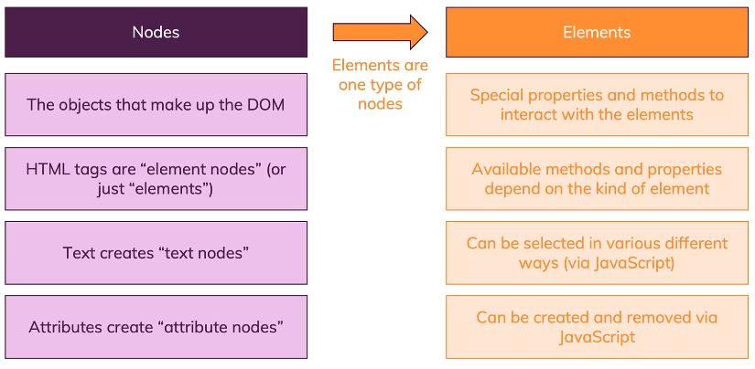

# Evaluating & Manipulating Elements

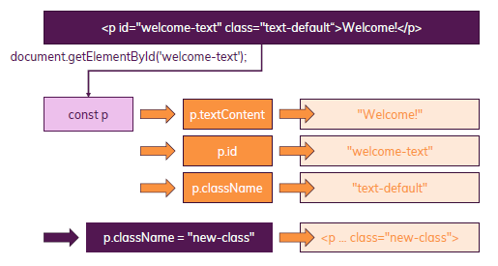

# Properties Vs Attributes

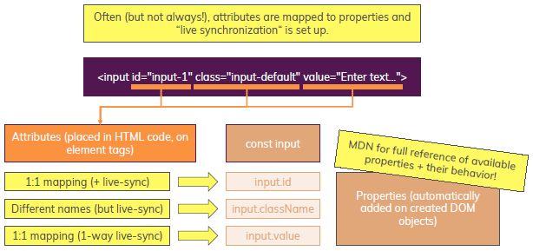

# Traversing the DOM [Children, Descendants, Parent and Ancestors]

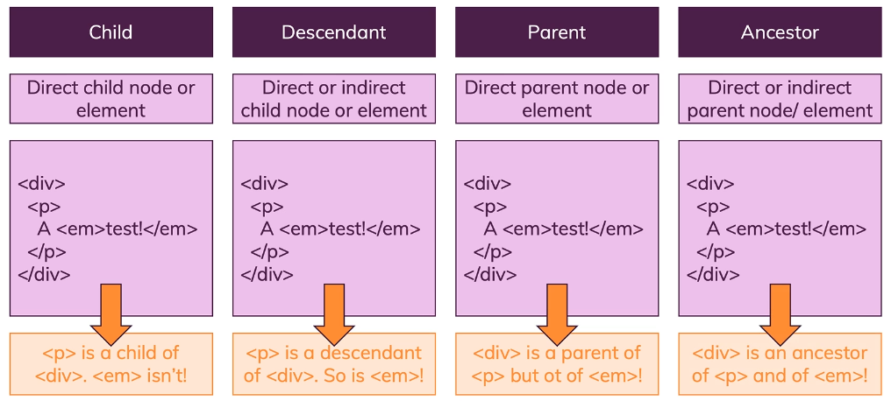

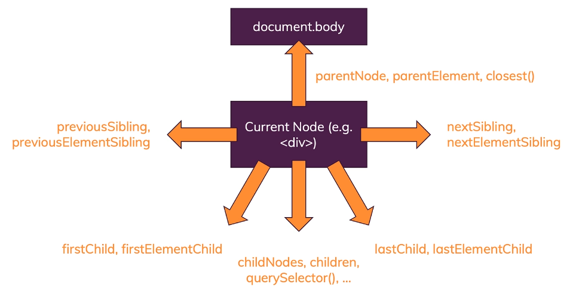

# Styling DOM Elements

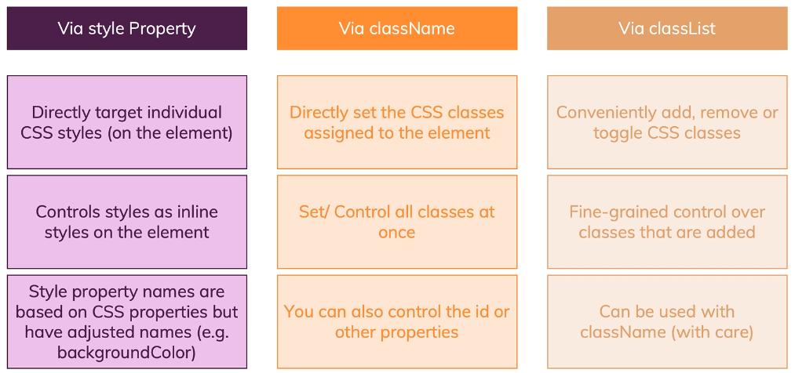

# Timing Events [setTimeout & setInterval]

The window object allows execution of code at specified time intervals. These time intervals are called timing events. The two key methods to use with JavaScript are:

* setTimeout(function, milliseconds)
  + Executes a function, after waiting a specified number of milliseconds.
* setInterval(function, milliseconds)
  + Same as setTimeout(), but repeats the execution of the function continuously.

# JavaScript Popup Boxes

* Alert
* Prompt
* Confirm

Look at following resource for more details:

<https://www.w3schools.com/js/js_popup.asp>

# Event Listeners – Add/Remove

W3Schools is a great resource to learn more about these:

<https://www.w3schools.com/js/js_htmldom_eventlistener.asp>

.addEventListener

element.addEventListener("click", myFunction);

function myFunction() {

alert ("Hello World!");

}

Or on window

window.addEventListener("resize", function(){

document.getElementById("demo").innerHTML = sometext;

});

And to remove the listener, use

element.removeEventListener("mousemove", myFunction);

## Events

Again, take a look at the W3Schools to learn more about the events available

<https://www.w3schools.com/js/js_htmldom_events.asp>